Fettuccine Alfredo

Recipe courtesy Emeril Lagasse, 2004

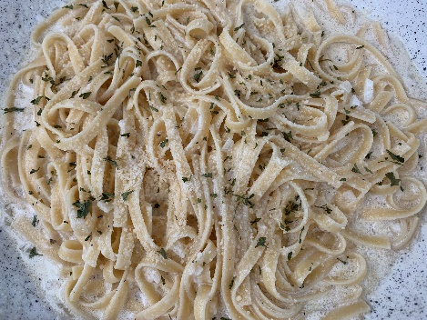Yield: Serves: 6

**Ingredients**

1. 1 pound dried or fresh fettuccine
2. ½ t. salt
3. 6 tablespoons unsalted butter
4. 2 shallots, minced
5. 1 cup heavy or light cream
6. 1 cup finely grated Parmesan Cheese (reserve 1/4 - 1/3 for topping)
7. 4 T. reserved pasta liquid (after boiling)
8. ¼ teaspoon ground black pepper
9. Fresh Parsley to garnish

**Directions - Pasta**

1. Fill soup pot 2/3 full of water. Add salt. Heat to boiling.
2. Add fettuccine noodles to the water. Cook following package directions. (~6-8 for fresh, ~11-13 for dry)
3. Drain pasta in colander reserving liquid for later use.
4. Return pasta to pot to keep warm until sauce is ready.

**Directions – Alfredo Sauce**

1. Meanwhile melt butter in medium saucepan over medium heat.
2. Add shallots and sauté until tender (about 5 minutes).
3. Reduce heat and add heavy or light cream, cheese, pasta water, black pepper. WARM the cream. Do not BOIL.
4. Add sauce to pasta.
5. Toss to combine thoroughly.
6. Sprinkle remaining parmesan cheese on top.

10.Garnish with parsley.

11.Serve immediately.